Visualization details:

If injection pressure > MAIP
A fracture will occur in the reservoir and the below animation shall be shown to the user (just for visualization)

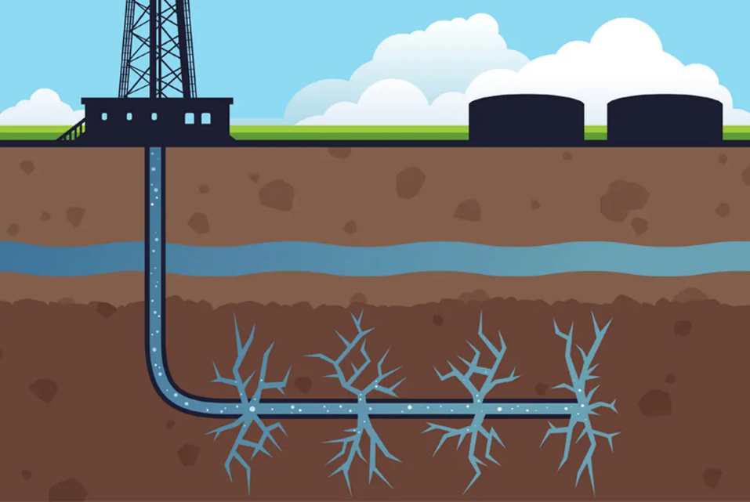
Image description:
Primary Subject: A 2D cross-section diagram of an underground well injection causing reservoir fractures. Art Style: Flat vector illustration, clean lines, solid colors, educational infographic style, 2D graphic design, no gradients or photorealism.
Scene Breakdown (Top to Bottom):
- Surface Level:
  - Background: A light blue sky with stylized, fluffy white clouds.
  - Ground Line: A simple horizontal strip of bright green grass.
  - Infrastructure: On the left, a flat black silhouette of an oil derrick positioned over a small foundation building with square windows. On the right, flat black silhouettes of two large cylindrical storage tanks.
- Subsurface Geological Layers:
  - Top Layer: A thick horizontal band of medium-brown soil or rock with subtle darker brown speckles.
  - Middle Layer: A wavy, solid horizontal blue band representing an underground water aquifer, sandwiched between the brown rock layers.
  - Bottom Layer: A thick, dark-brown rock formation layer representing the target reservoir.
- Wellbore and Fluid Action (The Main Event):
  - The Pipe: A distinct casing pipe runs vertically down from the surface rig, passing cleanly through the top brown layer and the blue aquifer layer. Once it reaches the bottom dark-brown layer, it curves 90 degrees to the right to form a horizontal wellbore.
  - The Fluid: Inside the pipe flows a light blue liquid with small white bubbles, representing the injected produced water.
  - The Fractures (The Leak): Along the horizontal section of the pipe, there are four distinct breakout zones. At each zone, jagged, branching cracks—resembling lightning bolts or tree roots—radiate violently upwards and downwards into the dark-brown rock. These deep fractures are filled with the same light blue fluid, clearly visualizing the high-pressure injection water breaking and leaking into the surrounding reservoir formation.

